Brice Baerga

October 14, 2020

Artificial Intelligence

Genetic Algorithm 2

1. Run your program 5 times with max generations = 2000 (you may go higher if needed). Run it 5 times with max generations of 50. Is your schedule evolving and is your fitness getting better in generation 50?

The general trend of both my average fitness and my maximum fitness seem to be going up, which would indicate that the schedule is indeed evolving. Analyzing the graphs I had made for each of the five runs, I would say that my fitness was more consistent and was in fact getting better in generation 50.

1. Run the GA 4 more times using baseline values except use the values of Pc = 0.25, 0.5, 0.75, and 1.0. Plot out the Max, and Average Fitness. for each run. X Generation number, Y Axis Fitness Fitness (max and avg). Note you will have 4 graphs.

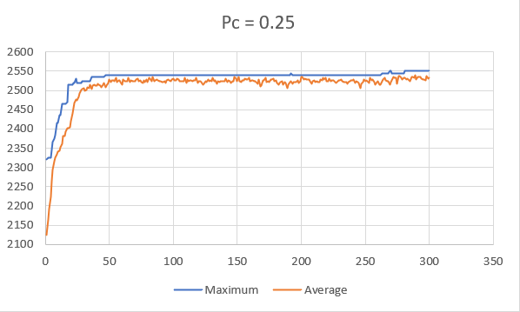

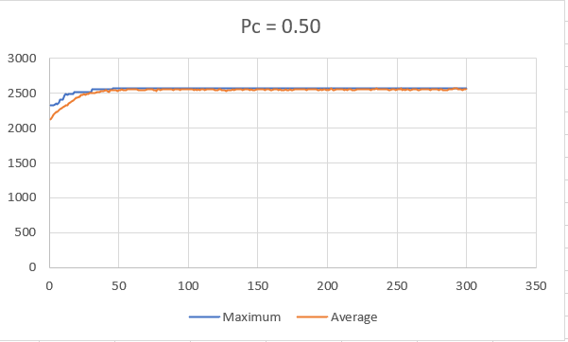

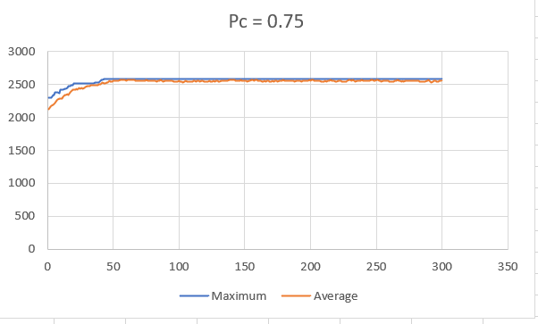

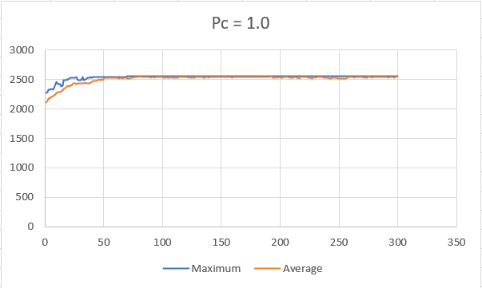

1. I can conclude the following about the charts. Whenever the crossover is .25, both maximum fitness and average fitness do not converge what so ever. However, as the probability of crossover increases, the two lines seem to converge quicker and quicker. In addition to that, the first 50 generations within each experiment seem to be always the most separate parts of the graph. After generation 50, the results converge much more steadily and much quicker.
2. The population converges quite quickly, being that it does it within the first 1/6 generations of the total number of generations. However, at .25, the fitness’s do not converge whatsoever.
3. Upon looking at the results, there does tend to be some premature convergences within both Pm = 0.50 and Pm = 1.0.
4. I can conclude that as the probability of crossover increases, the more and more likely it is for the populations to converge quicker. However, at an exceptional rate or too low of a rate, the convergences seem to be either non-existent or fairly premature.
5. Run the GA 5 more times using baseline values except use the values of Pm = 0.001, 0.002, 0.01, 0.05, 0.1. Plot out the Max, and Average Fitness. for each run. X Generation number, Y Axis Fitness Fitness (max and avg). Note you will have 5 graphs.
6. I can conclude, using the charts, that as the probability of mutation increases the probability of convergence also increases. The lines seem increase rather quickly, however, they rarely ever converge in the lower probabilities of mutation. Around 25 generations, there is a massive slope from 0-25 that happens within all of the graphs as well.
7. The populations do not quite seem to converge within the graphs well at all. It seems as if the closest the graphs got to converging, and possibly did converge, lies within Pm = 0.05 and Pm = 0.10.
8. The graphs do not seem to prematurely converge. In fact, its hard to tell whether they did or not. However, if there were any possible premature convergence detected, I would have to say it lies within Pm = 0.05 or Pm = 0.10.
9. I can conclude that as the probability of mutation increases, the probability of convergence increases with it.

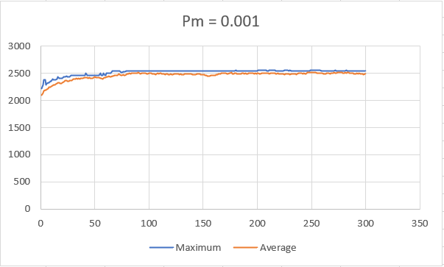

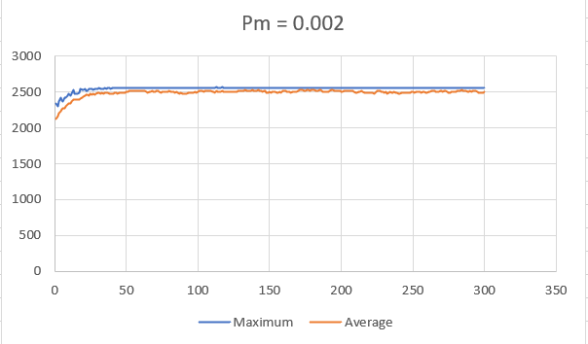

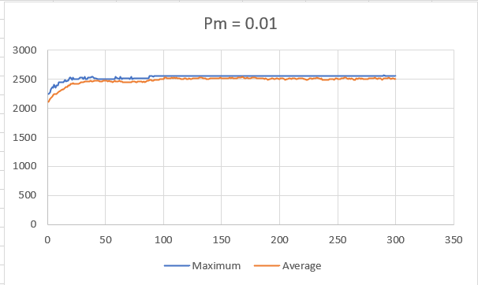

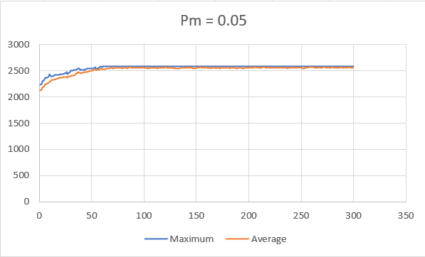

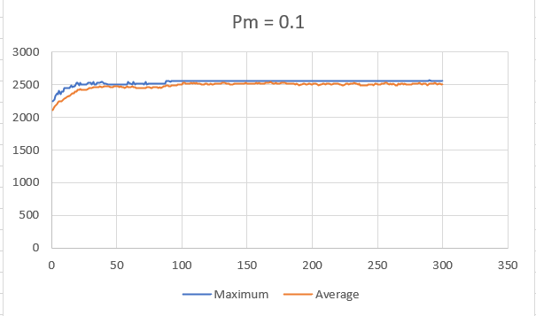

1. Run the GA 6 more times using baseline values except use the values of N = 10, 20, 50, 100, 500, 1000. Plot out the Max, and Average Fitness. for each run. X Generation number, Y Axis Fitness Fitness (max and avg). Note you will have 6 graphs.

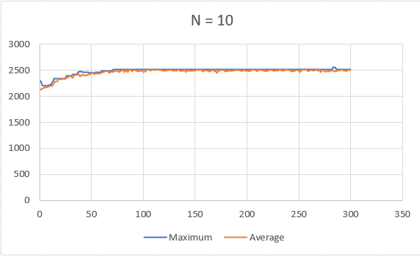

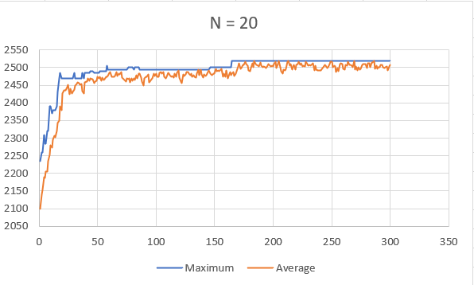

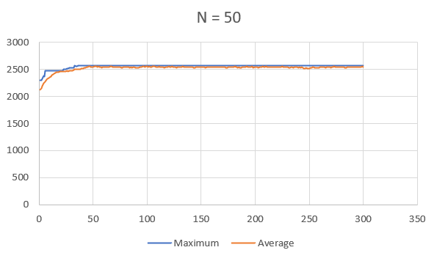

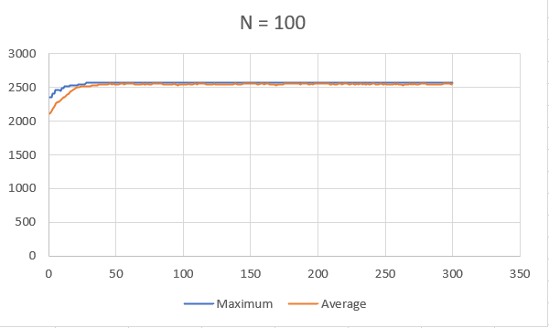

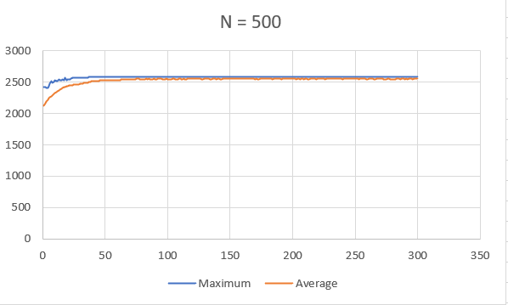

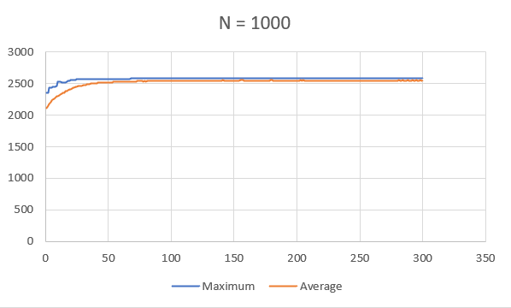

\*\*I decided to change my fitness score computation to a lower value to really be able to see how drastic these results are\*\*

This is what that is:

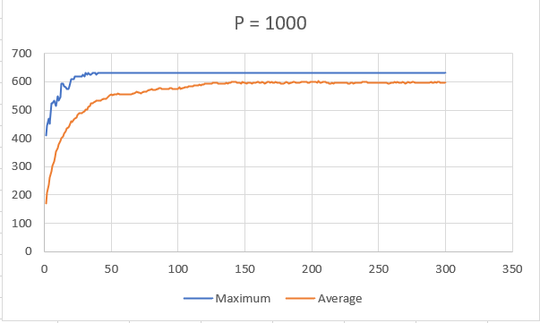

1. I can conclude that within the charts, as the size of the population increases, the harder it is for the algorithm to converge. Unlike the other charts, this peculiar scenario takes longer for the results to steady out. Instead of the 25-50 generation mark, we’re looking at about the 100-150 mark for fitness’s to level.
2. The convergence rate of the population within these charts does not happen all too quickly. However, convergence does occur within the first chart but very prematurely.
3. There is premature convergence within the first chart. It also occurs multiple times.
4. I can conclude that as the size of the population increases, the harder it is for the schedules to be completely optimized, meaning they have not converged.